
Multi Area Ospf Lab
By: Alen Sheen
Objective:
This lab aimed to investigate and implement Multi-Area OSPF (Open Shortest Path First) routing, essential for the effective management of extensive networks. By setting up and resolving issues in a multi-area OSPF configuration, the process of forming OSPF adjacencies and distributing routing information among various areas was explored. This experience enhanced the understanding of routing concepts, increased network scalability, and improved the operation of intricate networks.

Background Information:
Routing Protocols: These are guidelines that routers follow to communicate and determine optimal paths for data transmission. OSPF is particularly suitable for larger networks.
Multi-Area Design: This approach divides routers into distinct sections, or areas, simplifying traffic management and troubleshooting.
OSPF Adjacencies: Routers must connect to exchange route information. These connections, known as adjacencies, are crucial for effective communication.
Link-State Advertisements (LSAs): These messages are used by routers to share network information, ensuring that all routers are updated on the best routes.
Routing Tables: After collecting data, routers formulate tables that depict the best routes, facilitating efficient data transmission.
Scalability: Multi-Area OSPF allows networks to expand without becoming disorganized, maintaining manageability.
Laboratory Summary: Multi-Area OSPF Configuration:
In this laboratory, the focus was on establishing Multi-Area OSPF to manage routing in a network with multiple areas. The goal was to observe how OSPF maintains organization and efficiency in a scalable framework.
Setup Overview:
- Network Structure:
- The network was organized with:
  - Area 0 (the backbone)
  - Area 1
  - Area 2
  - Area 3
- Each router was designated to a specific area, while one router served as the central connector for all areas.
- Interface Configuration:
- Each router was assigned a unique IP address to enable smooth communication within the network.
- OSPF Setup:
- OSPF was activated on each router, and router IDs were assigned.
- Each router was configured to recognize its respective area. For instance, Router A was configured for Area 0 and was linked to the central router that managed inter-area communication.
Example configuration for Router A:
router ospf one
network 192.168.1.0 0.0.0.3 area 0
network 192.168.1.4 0.0.0.3 area 0
- Verification:
- The OSPF configuration was validated using commands such as show ip ospf neighbor and show ip route to confirm proper functionality.
- It was satisfying to observe all routers exchanging routes and maintaining effective connectivity.
Achievements:
- OSPF was successfully configured to enable communication among devices across different areas, ensuring smooth traffic through the backbone.
- Confirmation that routes were accurately exchanged, resulting in seamless connections throughout the network.
- The impact of various area types on routing performance was assessed, providing valuable insights into network optimization.
Conclusion:
This laboratory provided a comprehensive introduction to Multi-Area OSPF and its role in structured routing management. It demonstrated how OSPF fosters organization in larger networks. Future laboratories could investigate advanced configurations such as route summarization and the optimization of OSPF timers for enhanced performance.

Lab Commands
R0(Area 0):
en
conf t
hostname R1
ipv6 unicast-routing
int g0/0/0
ip address 192.168.0.2 255.255.255.0
ipv6 address 2001:db8:acad:b::2/64
ipv6 ospf 1 area 0
ip ospf 1 area 0
no shut
int g0/0/1
ip address 192.168.1.1 255.255.255.0
ipv6 address 2001:db8:acad:e::1/64
ip ospf 1 area 0
ipv6 ospf 1 area 0
no shut
router ospf 1
router-id 1.1.1.1
network 192.168.1.0 0.0.0.255 area 0
network 192.168.10.0 0.0.0.255 area 0
exit

R1(Area 1):
en
conf t
hostname R1
ipv6 unicast-routing
int g0/0/0
ip address 192.168.1.2 255.255.255.0
ipv6 address 2001:db8:acad:b::2/64
ipv6 ospf 1 area 0
ip ospf 1 area 0
no shut
int g0/0/1
ip address 192.168.10.1 255.255.255.0
ipv6 address 2001:db8:acad:e::1/64
ip ospf 1 area 0
ipv6 ospf 1 area 0
no shut
router ospf 1
router-id 1.1.1.1
network 192.168.1.0 0.0.0.255 area 0
network 192.168.10.0 0.0.0.255 area 0
exit

R2(Area 0):
en
conf t
hostname R2
ipv6 unicast-routing
int g0/0/0
ip address 192.168.4.1 255.255.255.0
ipv6 address 2001:db8:acad:d::1/64
ipv6 ospf 1 area 0
no shut
int g0/0/1
ip address 192.168.0.1 255.255.255.0
ipv6 address 2001:db8:acad:a::1/64
ipv6 ospf 1 area 1
ip ospf 1 area 1
no shut
router ospf 1
router id 2.2.2.2
network 192.168.0.0 0.0.0.255 area 1
network 192.168.4.0 0.0.0.255 area 0

ipv6 router ospf 1
network

R3(Area 0)
en
conf t
hostname R3
ipv6 unicast-routing
int g0/0/0
ip address 192.168.0.2 255.255.255.0
ipv6 address 2001:db8:acad:b::2/64
ipv6 ospf 1 area 1
int g0/0/1
ip address 192.168.2.4 255.255.255.0
ipv6 address 2001:db8:acad:c::5/64
ipv6 ospf 1 area 2
no shut
router ospf 1
network 192.168.2.0 0.0.0.255 area 2
network 192.168.0.0 0.0.0.255 area 1
exit

R4(Area 2)
en
conf t
hostname R3
ipv6 unicast-routing
int g0/0/0
ip address 192.168.0.2 255.255.255.0
ipv6 address 2001:db8:acad:b::2/64
ipv6 ospf 1 area 2
int g0/0/1
ip address 192.168.2.4 255.255.255.0
ipv6 address 2001:db8:acad:c::5/64
ipv6 ospf 1 area 2
no shut
router ospf 1
network 192.168.2.0 0.0.0.255 area 2
network 192.168.0.0 0.0.0.255 area 2
exit

R5(Area 2)
en
conf t
hostname R3
ipv6 unicast-routing
int g0/0/0
ip address 192.168.0.2 255.255.255.0
ipv6 address 2001:db8:acad:b::2/64
ipv6 ospf 1 area 2
int g0/0/1
ip address 192.168.2.4 255.255.255.0
ipv6 address 2001:db8:acad:c::5/64
ipv6 ospf 1 area 2
no shut
router ospf 1
network 192.168.2.0 0.0.0.255 area 2
network 192.168.0.0 0.0.0.255 area 2
exit

Multilayer Switch (Area 1)
en
conf t
ip routing
ipv6 unicast-routing
hostname S1
int f0/1
no switchport
ip add 192.168.1.1 255.255.255.0
ipv6 address 2001:db8:acad:b::1/64
ipv6 ospf 1 area 2
ip ospf 1 area 2
no shut
int f0/2
no switchport
ip add 192.168.4.2 255.255.255.0
ipv6 address 2001:db8:acad:d::2/64
ipv6 ospf 1 area 2
ip ospf 1 area 2
no shut
router ospf 1
router-id 2.2.2.2
network 192.168.1.0 0.0.0.255 area 2
network 192.168.0.0 0.0.0.255 area 2
network 192.168.4.0 0.0.0.255 area 2
Network Diagram:
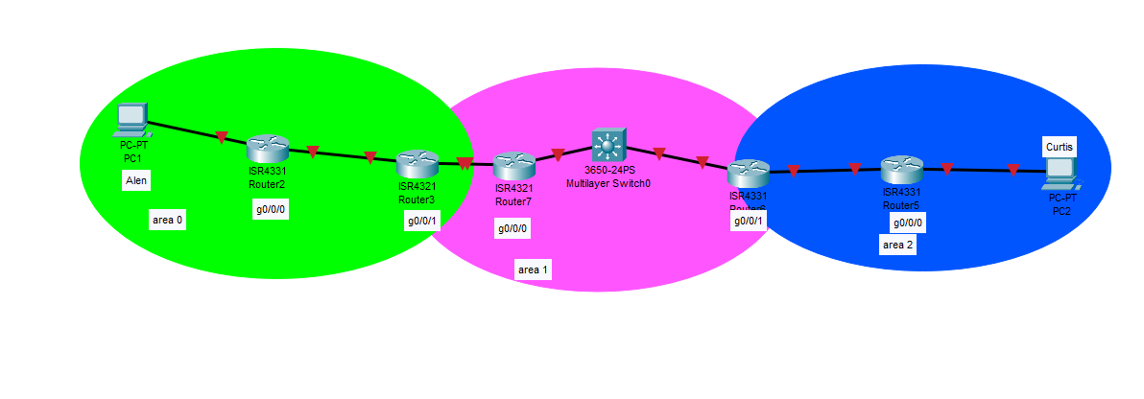
Configuration:
Building configuration...
Current configuration: 3870 bytes
Last configuration change at 22:36:54 UTC Tue Sep 24 2024
version 15.5
service timestamps debug datetime msec service timestamps log datetime msec no platform punt-keepalive disable-kernel-core
hostname R1
boot-start-marker boot-end-marker
yet definition Ngnt-intf
address-family ipv4 exit-address-family
address-family ipv6 exit-address-family
no aaa new-model
login on-success log ipv6 unicast-routing
subscriber templating
vt domain cisco
vtp mode transparent
multilink bundle-name authenticated
crypto pki tcustroint TP-self-signed-2189345785
enrollment selfsigned
subject-name so-IOS-Self-Signed-Certificate-2189345785
revocation-check none
csakeypair TP-self-signed-2189345785
crypto pki certificate chain TP-self-signed-2189345785
certificate self-signed 01
quit
license udi pid ISR4321/K9 so FD021281AAT
spanning-tree extend system-id
redundancy mode none
Xlao internal allocation policy ascending
interface GigabitEthernet0/0/0
ip address 192.168.1.1 255.255.255.252
negotiation auto ipv6 address 1::1/64
ipv6 ospf 1 area 0
interface GigabitEthernet0/0/1
ip address 192.168.1.5 255.255.255.252
negotiation auto ipv6 address 5::1/64
ipv6 enable
ipv6 ospf 1 area 1
interface GigabitEthernet0/1/0
negotiation auto
interface GigabitEthernet0/1/1
negotiation auto
interface Service-Engine0/2/0
no ip address
interface GigabitEthernet0
xxf forwarding Mgot-intf
no ip address shutdown
negotiation auto
interface Vlan1
no ip address
shutdown
router ospf 1
router-id 1.1.1.1
network 192.168.1.0 0.0.0.3 area 0
network 192.168.1.4 0.0.0.3 area 1
ip forward-protocol nd
no ip http server
no ip http secure-server
no ip Iftp source-interface GigabitEtherneto
ipv6 router espf 1 router-id 1.1.1.1
control-plane
line con e stephits 1
line aux e stopoits 1
line xty 0 4
login
end

Problems:
In this lab, we had a lot of problems with IP address and rack organization. At first, the devices could not ping each other, which showed that our subnetting or address strategies might have been wrong. We looked at each device’s IP configuration and subnet masks and used commands like show ip interface brief to find any problems. After making the necessary adjustments, we did several ping tests to verify connectivity, which took multiple attempts to succeed. Also, the way the rack was set up made it hard to figure out what was wrong. So, we moved the wires around to make them easier to see and use. This experience helped us understand subnetting and improve our ability to troubleshoot in both software and physical situations. It showed how important it is to be precise and organized in network setups. Overall, we gained important insights that we plan to record and expand upon in future projects.

Conclusion:
In this lab focused on Multi-Area OSPF, we aimed to set up and troubleshoot OSPF configurations across different areas to enhance routing efficiency. We successfully configured OSPF on multiple routers, ensuring effective communication between each area and the backbone area. However, we initially faced issues with area configurations and discrepancies in the routing tables, which prevented some routers from establishing neighbor relationships. After troubleshooting and checking interface statuses, along with commands like show ip ospf neighbor, we were able to identify and resolve these problems.
